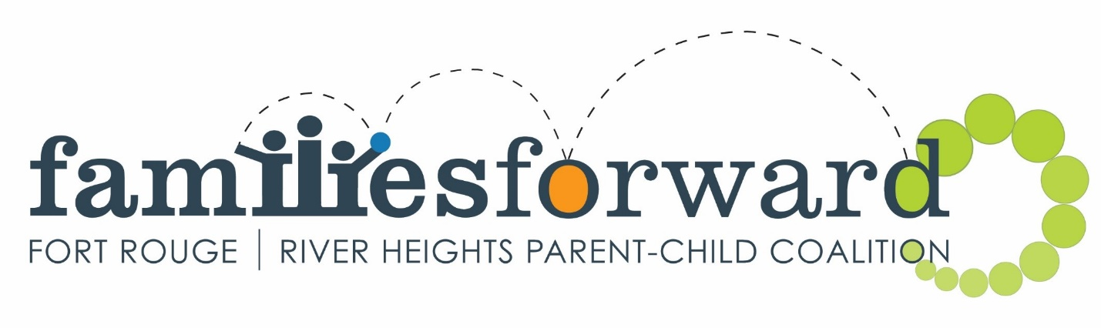

JOB OPPORTUNITY: Kids@Play Co-Facilitator

familiesforward is looking for organized and fun-loving individuals to join our team as part-time facilitators (approximately 3 - 9 hours a week) starting mid-January 2023. The successful candidates will co-facilitate Kids@Play, a weekly parent-child drop-in program run by the Fort Rouge/ River Heights Parent-Child Coalition. Programs currently run Tuesday and Thursday mornings with the aim to expand.

If you enjoy working with young children, planning activities and talking to parents, we’d like to hear from you! We welcome applications from all backgrounds, including minorities and individuals with a disability. Additional spoken languages are an asset.

familiesforward, Fort Rouge/ River Heights Parent-Child Coalition is funded by the Government of Manitoba, Department of Families. We work with community partners to support young families with children aged 0 - 6 years through programming that supports our four pillars: Learning and Literacy, Positive Parenting, Nutrition and Healthy Living, and Community Capacity Building. Kids@Play is a drop-in playgroup for children aged 0 – 6 years and their accompanying parents/ guardians. It includes active free play, songs, stories, games, crafts and a healthy snack.

To apply, please email a cover letter and resume to ffadmin@swfic.org .

Last updated November 23, 2022

DETAILED JOB DESCRIPTION: Kids@Play Co-Facilitator

Duties & Responsibilities:

- Co-facilitate parent-child drop-in programs
- Plan programming with co-facilitator for all Kids@Play sites (e.g. crafts, sensory table, songs, snacks)
- Make recommendations to the Board regarding community needs
- Encourage community members to be actively involved in familiesforward
- Submit receipts and mileage each month in a timely manner
- Shop for supplies and groceries as required
- Participate in and promote special events planned by familiesforward (literacy day, wind-up celebrations, summer festival, etc.)
- Attend and contribute to staff meetings and program planning sessions
- Participate in professional development (approved in advance by the familiesforward Coordinator). Training costs will be paid by familiesforward.

Requirements:

- Experience/ knowledge of child development, parent-child programming and/ or physical literacy
- A love of young children and the ability to support parents in their relationship with their child
- Dynamic and energetic approach to implementing programming
- Comfortable leading group activities (e.g. singing songs, reading stories)
- Comfortable outdoors for extended periods of time in all seasons
- Ability to lift toys and bins during setup and cleanup
- Access to a car for work is an asset
- Additional languages are an asset
- Current First Aid certification*
- Current Food Handler Certificate*
- Current Child Abuse Registry (with Vulnerable Sector search) and Criminal Record checks*

*familiesforward can assist the right candidates in getting their checks, first aid, and food handler certificates.

Hours:
- Variable, depending on the number of programs and sites running
- Mutually agreed upon for meetings and special events
- Kids@Play programming does not run during the Christmas break and is limited in the summer.

Remuneration: $15 - $16/ hour + 4% vacation pay, dependent on qualifications

Mileage: Reimbursement for work-specific travel (Note: This does not include mileage between the home and workplace.)

Accountability: This position is under the direct supervision of and accountable to the familiesforward coalition Coordinator. A performance review will be conducted annually.

