Where do you want to Play Today?
FREE Family Drop-In Programs for Fort Rouge/River Heights
Winter 2020 *updated Jan. 8, 2020

Monday | Tuesday | Wednesday | Thursday | Friday | Saturday
Kids@Play  (0-6yrs)  Crescent Fort Rouge United Church*  525 Wardlaw Ave.  9:30 - 11:30 AM  Begins January 13 | Kids@Play  (0-6yrs)  Bethel Mennonite Church  465 Stafford St.  9:30 - 11:30 AM  Begins January 14 | Kids@Play  (0-6 yrs)  Lord Roberts CC  725 Kylemore Ave.  9:30 - 11:30 AM  Begins January 15 | Kids@Play  (0-6yrs)  Carpathia School  300 Carpathia Rd  9:30 - 11:30 AM  Begins January 16 | Rhyme & Story time  (0-6 yrs)  Harrow United Church  955 Mulvey Ave.  9:30 - 11:30 AM  ongoing | Kids@Play  (0-6yrs)  Crescentwood CC  1170 Corydon Ave.  9:30 - 11:30 AM  Begins January 11
*Stairway access only at this site | Families Connecting  (prenatal – 12 months)  Child minding for siblings  Lord Roberts CC  725 Kylemore Ave.  9:45 - 11:45 AM  ongoing | Families Connecting  (Prenatal – 12 months)  Child minding for siblings  Mayfair Rec. Centre  40 Mayfair Pl.  9:45 - 11:45 AM  ongoing |  | Free Programs!  No pre-registration needed.  Drop in when you can.
Indoor Playground
(0-5 yrs)
River Heights CC
1370 Grosvenor Ave.
9:15 - 11:15 AM
Begins January 8

Kids@Play is working to be an inclusive environment for children of all abilities and needs. If your child would benefit from meeting our staff, exploring the space, and seeing the toys to become more comfortable prior to joining us during regular programming, we would be happy to arrange that for any site. Call Carrie at 204-791-0956 to arrange or discuss how we can make your experience better.
Program Contacts:
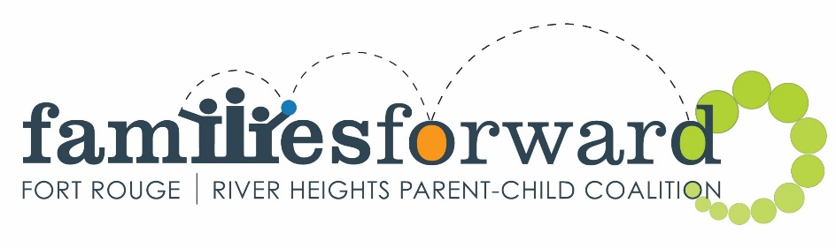
Kids@Play – Carrie 204-791-0956 www.families-forward.com Facebook: Families Forward – Fort Rouge/River Heights
Families Connecting – Healthy Baby – Run by Women’s Health Clinic – Contact Tracy 204.947.2422 ext.113 http://womenshealthclinic.org/
Rhyme & Story time – Harrow United church 204.284.0079
Indoor Playground – Central Corydon Community Club – River Heights location – 204.488.7000

Questions? familiesforward@swfic.org, 204.791.0956 or www.families-forward.com for up-to-date program changes

