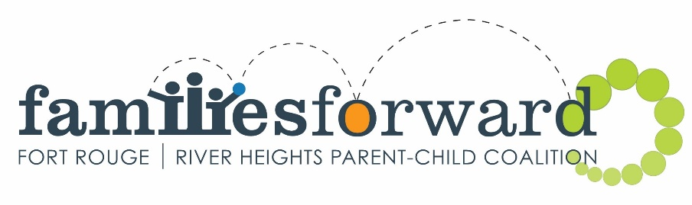
FUNDING GUIDELINES and CRITERIA
Application deadline February 14, 2020
Familiesforward is accepting applications for projects from April 1, 2020-September 1, 2020. We normally accept yearlong projects at this time, but for this fiscal year, we will be splitting our grant call. Pending funding confirmation, we will put out another call for grants in June for grants from September 1, 2020 to March 31, 2021. An extension of already approved programs may also be available at this time.

We financially support projects that strengthen our guiding principles: learning and literacy; nutrition and physical health; positive parenting; and community capacity building. If your organization has a project in mind, we encourage you to apply now.

The deadline for applications is February 14, 2020.

The maximum funding for any project remains at $5,000.00.

APPLICATION GUIDELINES:
- Organizations must be incorporated. (Grassroots projects may apply if working in partnership with an incorporated body.)
- Organizations/location of project must be located within the geographic areas of Fort Rouge or River Heights.
- Projects must primarily benefit the people of Fort Rouge and/or River Heights.
- Projects must fall under one of the following guiding principles: learning and literacy; nutrition and physical health; positive parenting; community capacity building.
- Applicants must establish that there is a need for the project and that other funding is unavailable.

Preference is given to projects which:
- Have a priority focus on the early years (0-6 years of age)
- Have not received prior funding from familiesforward.
- Encourage more efficient use of community resources.
- Promote accessibility to persons with unique needs (physical, emotional, cognitive challenges).
- Promote cooperation and networking among organizations to avoid duplication of services.

Grants are not usually awarded to:
- Provide salaries, unless the program cannot operate without some financial assistance towards salaries.
- Provide toys or books, unless it is part of a larger application for running a program and the items are required to run that program.

Grants are not awarded to or for:
- For profit organizations or businesses
- Capital projects
- Play structures
- Breakfast or lunch programs
- Furniture or appliances, shelving/storage units
- Computer hardware/software (except software for special needs)
- Office equipment such as photocopiers, fax machines, laminators
- Other equipment such as CD players, stereo systems, digital cameras, scanners
- Religious ceremonies, i.e. pow wows

Recognition
- Organizations that receive grant funding must:
  - display familiesforward signage;
  - display funding recognition book labels or stickers on project purchases where appropriate;
  - be profiled in the familiesforward newsletter, calendar, facebook page and webpage if approached by the coalition.
  - include recognition and the familiesforward logo on any material promoting the funded project/program (posters, flyers, etc)
  - provide a familiesforward webpage link on the organization’s website.
  - Attend annual familiesforward coalition meetings and prepare a presentation for the coalition on request.

Facilities Rental Subsidy
- In order to provide an equitable allocation of funds to organizations, we have determined a Facilities Rental Subsidy to be $10 per use/week (to be reviewed yearly).

Financial Support for Facilitators
- Maximums for Facilitator Support – Facilitator $17/hour; Co-facilitator $16.00/hour; Child Minder-current minimum wage. Organizations are free to set their own salary scales, however, familiesforward will provide salary support only up to the maximums listed here.

FUNDING CRITERIA:
- Minimum requirements must be met in order to be eligible to receive funding to run programs:
  - Program administrator, staff and volunteers must have a Criminal Records Check and Child Abuse Registry Check and be able to provide copies for familiesforward upon request when a site visit is done. For determination of which staff or volunteers need to meet these requirements, it is those staff or volunteers who may be left alone with children, i.e. in isolation with children, toileting, changing of clothes.
  - Program administrator or at least one staff on site must have a current First Aid/CPR certificate and be able to provide a copy to familiesforward upon request when a site visit is done.
  - Funded organizations will be required to undergo a site visit and meet recommended requirements for parent child programs as per Healthy Child Manitoba guidelines.
  - No program will be funded when hot beverages are being consumed in the area where children are participating in the program.
  - Please note, you must complete both an application form and a best practices checklist for parent child grants form for your application to be complete.
familiesforward will provide assistance to organizations to meet recommended requirements.

GRANT PAYMENTS:
One-time event Grants
- 90% upon submission of receipts and final report to familiesforward
- 10% after participation in a familiesforward coalition meeting and presentation.
April-September Grants
- 50% upon submission and completion of grant agreement to familiesforward only after familiesforward receives the first quarterly operating grant payment from Healthy Child Manitoba Office (HCMO).
- 30% after familiesforward receives their 2nd Quarter funding from HCMO. (Usually in Early August)
- 20% holdback upon program completion, full receipt submission, completed program evaluation and participation in a familiesforward coalition meeting and presentation.

If you have any questions regarding the application process, please do not hesitate to call Carrie at (204) 791-0956.

