Free Fall 2019
Family
Drop-In

Active free play, crafts, songs and games.
Healthy snack provided. No pre-registration needed.
0-6 years with their parents/caregivers.
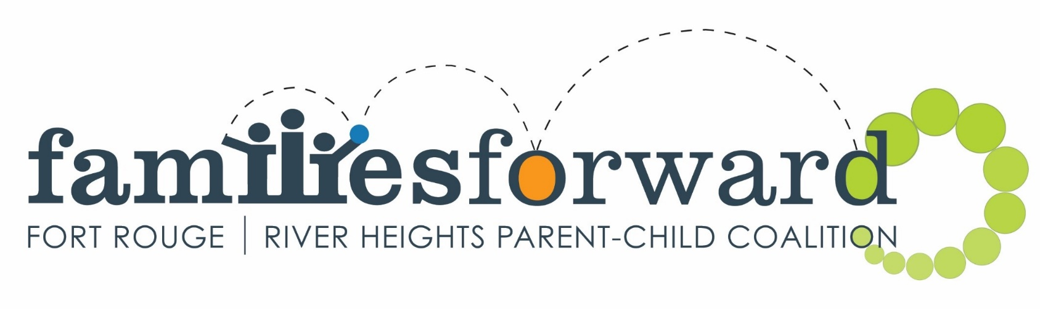
Monday  Begins Sept 23  9:30-11:30 am  525 Wardlaw Ave  (Crescent Fort Rouge Church) | Tuesday  Begins Sept 24  9:30-11:30 am  465 Stafford St.  (Bethel Mennonite Church) | Wednesday  Begins Sept 25  9:30-11:30 am  725 Kylemore Ave.  (Lord Roberts Community Centre)
Thursday  Begins Sept 26  9:30-11:30am  300 Carpathia St  (Carpathia School)  Kids@Play is a community program by | Saturday  Begins Sept 21*  9:30-11:30 am  1170 Corydon Ave  (Crescentwood Site of Corydon Community Centre.)  *We will be outside at this  site on Sept 21 & 28. | Summer Kids@Play is Outside!  10am-11:30am  June 27 July 4, 11, 18  1170 Corydon Ave  (Crescentwood Site of Corydon Community Centre.)

Follow us on Facebook | Families Forward – Fort Rouge/River Heights | www.families-forward.com
Instagram, Twitter
204.791.0956 | familiesforward@swfic.org |

Supported by Healthy Child Manitoba “Putting Children and Families First”

