Where do you want to Play Today?
FREE Family Drop-In Programs for Fort Rouge/River Heights
Fall 2019

Monday | Tuesday | Wednesday | Thursday | Friday | Saturday
Kids@Play  (0-6yrs)  Crescent Fort Rouge United Church*  525 Wardlaw Ave  9:30-11:30  Begins September 23 | Kids@Play  (0-6yrs)  Bethel Mennonite Church  465 Stafford St  9:30-11:30  Begins September 24 | Kids@Play  (0-6 yrs.)  Lord Roberts  Community Centre  725 Kylemore Ave  9:30-11:30  Begins September 25 | Kids@Play  (0-6yrs)  Carpathia School  300 Carpathia Rd  9:30-11:30  Begins September 26 | Rhyme & Story time  (0-6 yrs.)  Harrow United Church  955 Mulvey Ave.  9:30-11:30  All Summer and Fall | Kids@Play  (0-6yrs)  Crescentwood  Community Centre  1170 Corydon Ave  9:30-11:30  Begins September 21
*This space is not accessible | Families Connecting  (prenatal – 12 months)  Child minding for siblings  Lord Roberts C.C.  725 Kylemore Ave.  9:45-11:45 – ongoing  *call for summer | Families Connecting  (Prenatal – 12 months)  Child minding for siblings  Mayfair Rec. Centre  40 Mayfair Pl.  9:45-11:45 – ongoing  *call for summer |  |  | Free Programs  No pre-registration needed.  Drop-in when you can.
Indoor Playground
(0-5 yrs.)
River Heights
Community Centre
1370 Grosvenor Ave
9:30-11:30
Begins mid-October

Kids@Play is working to be an inclusive environment for children of all abilities and needs. If your child would benefit from meeting our staff, exploring the space, and seeing the toys to become more comfortable prior to joining us during regular programming, we would be happy to arrange that for any site. Call Carrie at 204-791-0956 to arrange or discuss how we can make your experience better.
Program Contacts:
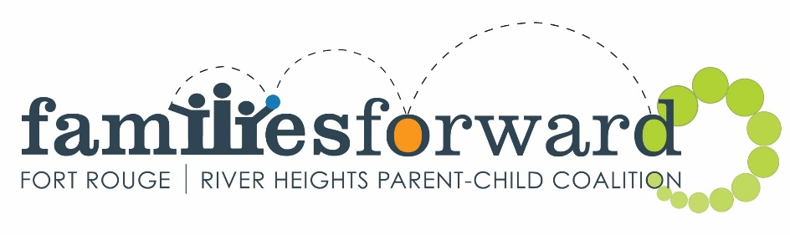
Kids@Play – Carrie 204-791-0956 www.families-forward.com Facebook: Families Forward – Fort Rouge/River Heights
Families Connecting – Healthy Baby – Run by Women’s Health Clinic – Contact Tracy 204.947.2422 ext.113 http://womenshealthclinic.org/
Rhyme & Story time – Harrow United church 204.284.0079
Indoor Playground – Central Corydon Community Club – River Heights location – 204.488.7000

Questions? familiesforward@swfic.org, 204.791.0956 or www.families-forward.com for up-to-date program changes

