Where do you want to Play Today?
FREE Family Drop-In Programs for Fort Rouge/River Heights
Spring & Summer 2019

Monday | Tuesday | Wednesday | Thursday | Friday | Saturday
Kids@Play  (0-6yrs)  Crescent Fort Rouge United Church*  525 Wardlaw Ave  9:30-11:30  Until June 3, 2019 | Kids@Play  (0-6yrs)  Bethel Mennonite Church  465 Stafford St  9:30-11:30  Until June 4, 2019 | Kids@Play  (0-6 yrs.)  Lord Roberts  Community Centre  725 Kylemore Ave  9:30-11:30  Until June 5, 2019 | Kids@Play  (0-6yrs)  Carpathia School  300 Carpathia Rd  9:30-11:30  Until June 6, 2019 | Rhyme & Story time  (0-6 yrs.)  Harrow United Church  955 Mulvey Ave.  9:30-11:30  All Spring and Summer | Kids@Play  (0-6yrs)  Crescentwood  Community Centre  1170 Corydon Ave  9:30-11:30  Until June 1, 2019
*This space is not accessible | Families Connecting  (prenatal – 12 months)  Child minding for siblings  Lord Roberts C.C.  725 Kylemore Ave.  9:45-11:45 - ongoing | Families Connecting  (Prenatal – 12 months)  Child minding for siblings  Mayfair Rec. Centre  40 Mayfair Pl.  9:45-11:45 - ongoing |  | NEW PLAY TOGETHER IN ANY WEATHER  Kids@Play moves outside for six weeks in June and July. We will be there no matter what the weather (we have spare boots and ponchos and a place to go inside for a few minutes if needed). Look for us in the field at Crescentwood Community Centre (1170 Corydon Ave). A free snack will be provided.  Thursdays 10am-11:30am  June 13, 20, 27 July 4, 11, 18  So come have fun in the rain or sun
Free Programs  No registration needed.  Drop-in when you can. |  | Indoor Playground  (0-5 yrs.)  River Heights  Community Centre  1370 Grosvenor Ave  9:30-11:30  Until May 15, 2019

Kids@Play is working to be an inclusive environment for children of all abilities and needs. If your child would benefit from meeting our staff, exploring the space, and seeing the toys to become more comfortable prior to joining us during regular programming, we would be happy to arrange that for any site. If there is something we can have available (or make sure not to have out) to make your family feel more comfortable and welcome, please let us know! Call Carrie at 204-791-0956 to arrange or discuss how we can make your experience better.
Program Contacts:
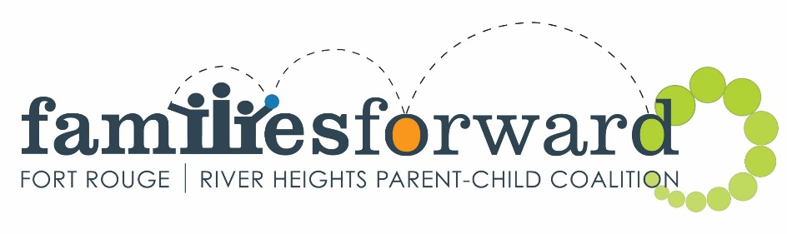
Kids@Play – Carrie 204-791-0956 www.families-forward.com Facebook: Families Forward – Fort Rouge/River Heights
Families Connecting – Healthy Baby – Run by Women’s Health Clinic – Contact Tracy 204.947.2422 ext.113 http://womenshealthclinic.org/
Rhyme & Story time – Harrow United church 204.284.0079
Indoor Playground – Central Corydon Community Club – River Heights location – 204.488.7000

Questions? familiesforward@swfic.org, 204.791.0956 or www.families-forward.com for up-to-date program changes

