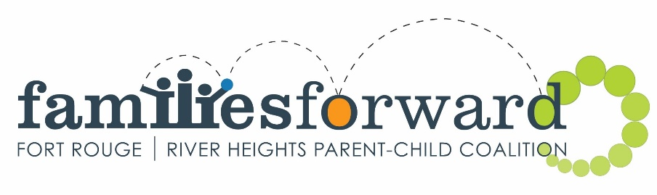
FUNDING GUIDELINES and CRITERIA
Application deadline February 25, 2019
familiesforward awards grant funding twice a year, March for Full year projects and Spring/Summer/Fall projects, and October for Winter projects if there are funds available. We financially support projects that strengthen our guiding principles: learning and literacy; nutrition and physical health; positive parenting; and community capacity building. We are currently accepting Applications for Funding for Full Year Projects (April 1, 2019- March 31, 2020) and Spring/Summer/Fall 2019 Projects. If your organization has a project in mind, we encourage you to apply now. The deadline for applications is February 25, 2019.

The maximum funding for any project remains at $5,000.00.

APPLICATION GUIDELINES:
- Organizations must be incorporated. (Grassroots projects may apply if working in partnership with an incorporated body.)
- Organizations/location of project must be located within the geographic areas of Fort Rouge or River Heights.
- Projects must primarily benefit the people of Fort Rouge and/or River Heights.
- Projects must fall under one of the following guiding principles: learning and literacy; nutrition and physical health; positive parenting; community capacity building.
- Applicants must establish that there is a need for the project and that other funding is unavailable.

Preference is given to projects which:
- Have a priority focus on the early years (0-6 years of age)
- Have not received prior funding from familiesforward.
- Encourage more efficient use of community resources.
- Promote accessibility to persons with unique needs (physical, emotional, cognitive challenges).
- Promote cooperation and networking among organizations to avoid duplication of services.

Grants are not usually awarded to:
- Provide salaries, unless the program cannot operate without some financial assistance towards salaries.
- Provide toys or books, unless it is part of a larger application for running a program and the items are required to run that program.

Grants are not awarded to or for:
- For profit organizations or businesses
- Capital projects
- Play structures
- Breakfast or lunch programs
- Furniture or appliances, shelving/storage units
- Computer hardware/software (except software for special needs)
- Office equipment such as photocopiers, fax machines, laminators
- Other equipment such as CD players, stereo systems, digital cameras, scanners
- Religious ceremonies, i.e. pow wows

Recognition
- Organizations that receive grant funding must:
  - display familiesforward signage;
  - display funding recognition book labels or stickers on project purchases where appropriate;
  - be profiled in the familiesforward newsletter, calendar, facebook page and webpage if approached by the coalition
  - include recognition and the familiesforward logo on any material promoting the funded project/program (posters, flyers, etc)
  - provide a familiesforward webpage link on the organization’s website.
  - Attend annual familiesforward coalition meetings and prepare a presentation for the coalition on request.

Facilities Rental Subsidy
- In order to provide an equitable allocation of funds to organizations, we have determined a Facilities Rental Subsidy to be $10 per use/week (to be reviewed yearly).

Financial Support for Facilitators
- Maximums for Facilitator Support – Facilitator $17/hour; Co-facilitator $15.00/hour; Child Minder-current minimum wage. Organizations are free to set their own salary scales, however, familiesforward will provide salary support only up to the maximums listed here.

FUNDING CRITERIA:
- Minimum requirements must be met in order to be eligible to receive funding to run programs:
  - Program administrator, staff and volunteers must have a Criminal Records Check and Child Abuse Registry Check and be able to provide copies for familiesforward upon request when a site visit is done. For determination of which staff or volunteers need to meet these requirements, it is those staff or volunteers who may be left alone with children, i.e. in isolation with children, toileting, changing of clothes.
  - Program administrator or at least one staff on site must have a current First Aid/CPR certificate and be able to provide a copy to familiesforward upon request when a site visit is done.
  - Funded organizations will be required to undergo a site visit and meet recommended requirements for parent child programs as per Healthy Child Manitoba guidelines.
  - No program will be funded when hot beverages are being consumed in the area where children are participating in the program.
familiesforward will provide assistance to organizations to meet recommended requirements.

GRANT PAYMENTS:
One-time event Grants
- 90% upon submission of receipts and final report to familiesforward
- 10% after participation in a familiesforward coalition meeting and presentation.
Spring/Summer/Fall Grants
- 50% upon submission and completion of grant agreement to familiesforward only after familiesforward receives the first quarterly operating grant payment from Healthy Child Manitoba Office (HCMO).
- 40% upon submission of receipts and final report to familiesforward
- 10% after participation in a program celebration hosted by familiesforward
Full Year Grants
- 25% upon receipt of acceptance letter and only after familiesforward receives the first quarterly operating grant payment from Healthy Child Manitoba Office (HCMO).
- 25% after familiesforward receives their 2nd Quarter funding from HCMO. (usually in Early September)
- 25% after submission of 1st half receipts, and mid-point evaluation (by September 15th) and after familiesforward receives their 3rd Quarter funding from HCMO. (October)
- 15% after familiesforward receives their 4th Quarter funding from HCMO. (January)
- 10% holdback upon program completion, full receipt submission, completed program evaluation and participation in a familiesforward coalition meeting and presentation.

If you have any questions regarding the application process, please do not hesitate to call Carrie at (204) 791-0956.

