Where do you want to Play Today?
FREE Family Drop-In Programs for Fort Rouge/River Heights
Winter 2019

Monday | Tuesday | Wednesday | Thursday | Friday | Saturday
Kids@Play  (0-6yrs)  Crescent Fort Rouge United Church  525 Wardlaw Ave  9:30-11:30  Jan 14-June* | Kids@Play  (0-6yrs)  Bethel Mennonite Church  465 Stafford St  9:30-11:30  Jan 15-June*  *CANCELLED FEB 12 | Kids@Play  (0-6 yrs.)  Lord Roberts  Community Centre  725 Kylemore Ave  9:30-11:30  Jan 16-June | Kids@Play  (0-6yrs)  Carpathia School  300 Carpathia Rd  9:30-11:30  Jan 17-June | Rhyme & Story time  (0-6 yrs.)  Harrow United Church  955 Mulvey Ave.  9:30-11:30  Jan 4 - ongoing | Kids@Play  (0-6yrs)  Crescentwood  Community Centre  1170 Corydon Ave  9:30-11:30  Jan 12-June*
*No program  Feb 18 Lois Riel Day  *This space is not accessible | Families Connecting  (prenatal – 12 months)  Child minding for siblings  Lord Roberts C.C.  725 Kylemore Ave.  9:45-11:45 | Families Connecting  (Prenatal – 12 months)  Child minding for siblings  Mayfair Rec. Centre  40 Mayfair Pl.  9:45-11:45 |  |  | *No Program Jan 26 because of the winter carnival.  Free Programs  No registration needed.  Drop-in when you can.
Indoor Playground
(0-5 yrs.)
River Heights
Community Centre
1370 Grosvenor Ave
9:30-11:30
Jan 9th - May

Kids@Play is working to be an inclusive environment for children of all abilities and needs. If your child would benefit from meeting our staff, exploring the space, and seeing the toys to become more comfortable prior to joining us during regular programming, we would be happy to arrange that for any site. If there is something we can have available (or make sure not to have out) to make your family feel more comfortable and welcome, please let us know! Call Carrie at 204-791-0956 to arrange or discuss how we can make your experience better.
Program Contacts:
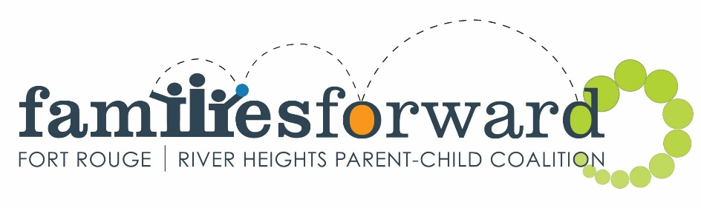
Kids@Play – Carrie 204-791-0956 www.families-forward.com Facebook: Families Forward – Fort Rouge/River Heights
Families Connecting – Healthy Baby – Run by Women’s Health Clinic – Contact Tracy 204.947.2422 ext.113 http://womenshealthclinic.org/
Rhyme & Story time – Harrow United church 204.284.0079
Indoor Playground – Central Corydon Community Club – River Heights location – 204.488.7000

Questions? familiesforward@swfic.org, 204.791.0956 or www.families-forward.com for up-to-date program changes

