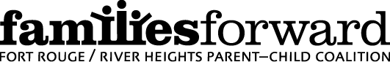

TERMS OF REFERENCE
April 2018

Mission Statement

familiesforward (Fort Rouge/River Heights Parent Child Coalition), supported by Healthy Child Manitoba is committed to nurturing healthy children, and families in the Fort Rouge/River Heights community. We service all families with children 0-6, with a priority focus on ages 1-4.

Goals

- To engage community partners from the public, private, volunteer and other sectors in a shared vision to support healthy children, families and communities.

- To establish a working coalition of community stakeholders to identify needs and priorities and to develop a sustainable plan for addressing those needs in a manner appropriate to the community.

- To support early childhood development and parenting activities that complement, build upon and enrich existing programs or introduce new programs to address identified gaps in services or resources.

- To promote healthy outcomes for children, and families through the priority activities of parenting, nutrition and healthy living, literacy and learning and community capacity building.

- To demonstrate the impact of initiatives through measuring and monitoring program outcomes, in partnership with Healthy Child Manitoba

Objectives

- Support learning, literacy/numeracy and language based activities in the community.

- Support healthy living and nutrition in the community.

- Support positive parenting.

- Support community capacity by fostering a sense of neighbourhood, inclusivity and maximization of community resources.

Members

This is a volunteer coalition comprised of representatives from all sectors of the community including and not limited to health, education, family services, child care, recreation services, faith organizations, business, parents and community members at large.
Membership types:
Active Coalition Members: attend meeting regularly and participate in committee work
Engaged Community Members: receive meeting minutes and attend meeting occasionally

Meetings

The full coalition will meet a minimum of four times annually. Sub-committees will meet as needed.
The coalition will meet according to the following calendar:

April: AGM
May: Executive meeting
June: Full membership with an optional PD presentation
July: break
August: Break
September: Executive Meeting
October: Full Membership and Selection committee meeting
November: Executive Meeting
December: Full membership with Potluck lunch
January: Break
February: Executive meeting
March: Full membership with program celebration and selection committee meeting

Geographic Boundaries

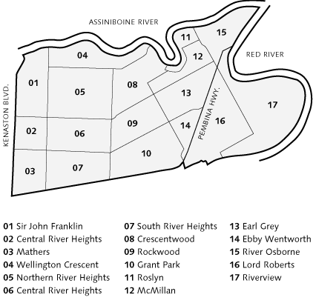

Authority

The coalition will use consensus as the procedure for decision making. If consensus cannot be attained the issue shall be put to a vote, requiring 75% majority in order to be carried.

All financial decisions shall require a recorded motion supported by 75% of the members present.

Quorum for familiesforward shall be 50% of active membership. Active membership will be determined annually at the anniversary date (April).

Structure

Healthy Child Manitoba
║
Executive
(2 Co-chairs, member at large, Banker)
Coordinator > ║ < Host Agency
I
Program Staff ║
Coalition Members
║
Standing Committees:
Selection
Personnel
║
Ad Hoc committees
║
Neighbourhood

Executive
The executive will consist of two co-chairs, a representative from the Host Agency (Banker) and a member-at-large. The executive will be elected each April at the AGM.

- Shall oversee the work of the coalition
- Shall convene a minimum of 4 coalition meetings per year
- Shall add other standing or ad-hoc committees as the need arises
- Shall ensure the work of the coalition is meeting the mandate of the terms of the reference
- Shall schedule a review of the terms of reference to ensure it is continuing to meet the needs of the community
- Shall provide direction to the Coordinator regarding her/his role and responsibilities as specified in the Coordinator’s job description. Shall complete an annual Personnel Evaluation for the Coordinator.

Chairperson
- A shared position of two co-chairs; terms of each co-chair shall be two years in length and shall be staggered
- Shall chair all meetings of the coalition and its executive
- Shall ensure that required documents are submitted in a timely fashion to Healthy Child Manitoba and other collateral agencies
- Representative to Healthy Child Manitoba

Member-at-Large
- A one year term position elected at the AGM each year.
- Shall participate on the executive committee
- Shall represent the coalition at HCM events if required

Coordinator
- Shall fulfill the responsibilities of secretary and shall keep minutes and provide reports to the coalition
- Shall record and circulate minutes of all coalition and executive meetings
- Shall keep an updated list of members
- Shall provide notice of meetings
- Shall coordinate monthly financial statements with the banker for review by the Coalition
- Shall be an ex-officio non-voting member
- Shall provide support and make recommendations to the Board regarding community needs
- Shall seek advice and guidance regarding issues and task/project direction
- Shall provide outreach to identified areas of the community at the grassroots level
- Shall connect individuals and families to programs and resources
- Shall perform site visits and act as a resource to funded programs and organizations
- Shall promote “On the Road to Best Practice”, training and professional development opportunities
- Shall encourage community members to be actively involved in familiesforward
- Shall maintain social media and online communication of the coalition
- Shall provide supervision and support to program staff hired to run coalition programming

Host Agency (Banker)
- Shall be the banker for the coalition (for purposes of financial reporting, our fiscal year will be April 1st to March 31st)
- Shall be an incorporated body
- Shall be responsible for receiving quarterly funds from Healthy Child Manitoba, depositing funds into the account that is held for familiesforward by the banker, and distributing the funds on behalf of familiesforward as directed by the Coordinator, as approved by the coalition.
- Shall be the signing authority on the bank account held by the banker for familiesforward
- Shall hold the employment contract for the Coordinator and all program staff.
- Shall be responsible for providing the Coordinator with monthly financial and banking information and semi-annual financial statements for submission to Healthy Child Manitoba

Grant Selection Committee
- Shall approve project funding for up to a maximum of $5,000 per project to community or non-profit organizations. (Organizations must be incorporated. Grassroots projects may apply if working in partnership with an incorporated body.)
- Shall recommend any project requesting funding over $5,000 to the coalition for approval by HCMO
- Shall meet as necessary to review applications for funding
- Shall establish and review guidelines, application procedures and evaluation forms
- Shall keep minutes and provide reports to the coalition
- Shall review and award requests for funding for training and professional development

Personnel Committee
- Shall be comprised of the two co-chairs of the coalition and a representative from the Host Agency
- Shall be responsible for hiring, supervision and direction of paid staff
- Shall meet as necessary with paid personnel

Active Coalition Member
- Shall attend meetings
- Shall participate on committees
- Shall promote the coalition
- Shall review terms of reference as needed
- Shall volunteer at Coalition events, if possible.

Revised: April. 2018

