Where do you want to Play Today?
FREE Family Drop-In Programs for Fort Rouge/River Heights
Winter 2018

Monday | Tuesday | Wednesday | Thursday | Friday | Saturday
Kids@Play  (0-6yrs)  Mayfair Rec. Centre  40 Mayfair Pl.  9:30-11:30  Jan 15-Mar 26 | Kids@Play  (0-6yrs)  Bethel Mennonite Church  465 Stafford St  9:30-11:30  Jan 16-Mar 27 | Kids@Play  (0-6 yrs.)  Lord Roberts C.C.  725 Kylemore Ave  9:30-11:30  Jan 17-Mar 28 | Kids@Play  (0-6yrs)  Crescentwood C.C  1170 Corydon Ave  9:30-11:30  Jan 18-Mar 29 | Rhyme & Story time  (0-6 yrs.)  Harrow United Church  955 Mulvey Ave.  9:30-11:30  Ongoing | Kids@Play  (0-6yrs)  Crescentwood C. C.  1170 Corydon Ave  9:30-11:30  Jan 13 – Mar 31
 | Families Connecting  (prenatal – 12 months)  Child minding for siblings  Lord Roberts C.C.  725 Kylemore Ave.  9:45-11:45 | Families Connecting  (Prenatal – 12 months)  Child minding for siblings  Mayfair Rec. Centre  40 Mayfair Pl.  9:45-11:45 | Kids@Play  (0-6 yrs.)  Sir John Franklin C.C.  1 Sir John Franklin Rd.  6:00 – 7:30 pm  Jan 18-Mar 29 |  | Free Programs  No registration needed.  Drop-in when you can.
Indoor Playground
(0-5 yrs.)
Central Corydon C.C.
1370 Grosvenor Ave
9:30-11:30
Oct 18-May 16

Kids@Play is working to be an inclusive environment for children of all abilities and needs. If your child would benefit from meeting our staff, exploring the space, and seeing the toys to become more comfortable prior to joining us during regular programming, we would be happy to arrange that for any site. If there is something we can have available (or make sure not to have out) to make your family feel more comfortable and welcome, please let us know! Call Carrie at 204-791-0956 to arrange or discuss how we can make your experience better.
Program Contacts:
Kids@Play – Carrie 204-791-0956 www.families-forward.com Facebook: Families Forward – Fort Rouge/River Heights
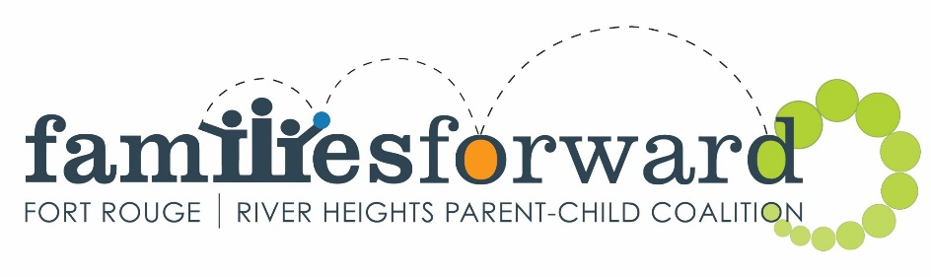
Families Connecting – Healthy Baby – Run by Women’s Health Clinic – Contact Tracy 204.947.2422 ext.113 http://womenshealthclinic.org/
Rhyme & Story time – Harrow United church 204.284.0079
Indoor Playground – Central Corydon Community Club – River Heights location – 204.488.7000

Questions? familiesforward@swfic.org, 204.791.0956 or www.families-forward.com for up-to-date program changes

