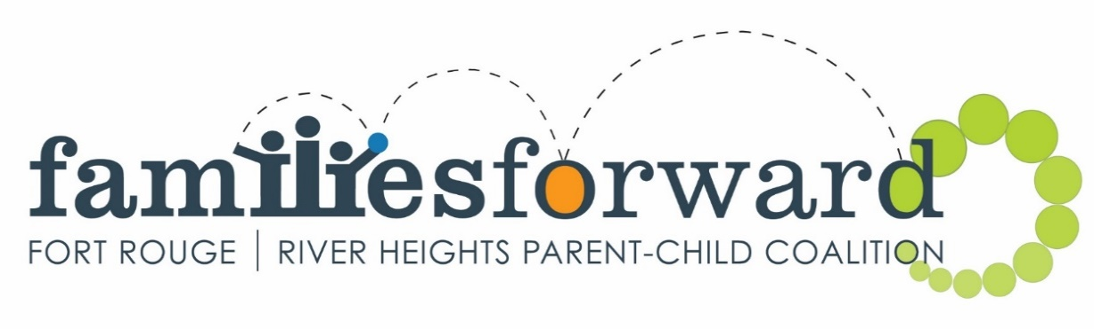
Free
Family Fun!
Active free play, circle time, healthy snack provided. Summer Fun for Families

July Drop-in  Wednesdays  9:30-11:30  Active free play, circle time, healthy snack provided.  July 5, 12, 19, 26  Lord Roberts Community Centre  725 Kylemore Ave.  Rhyme & Storytime  Friday mornings all summer | 9:30-11:30  Harrow United Church | 955 Mulvey Ave. | Outside Play  Tuesdays in July  10:00-11:30  Drop by and join us each week at a local playground for active summer fun! Bring your water bottle, hat and sunscreen.  July 4th – Harrow Park  Harrow @ Fleet  July 11th – Fort Rouge Park  River Ave. @ Lewis  July 18st – Montrose Park  Montrose @ Fleet  July 25th - William Osler Park  Brock @ Mathers  Cancelled in the rain. Will be posted on Facebook
***PLEASE NOTE: For safety reasons, no hot beverages are allowed at any Kids@Play programs***

Follow us on Facebook Families Forward – Fort Rouge/River Heights | www.families-forward.com

204.791.0956 | familiesforward@swfic.org | 204.804.7781

Supported by Healthy Child Manitoba “Putting children and families first”

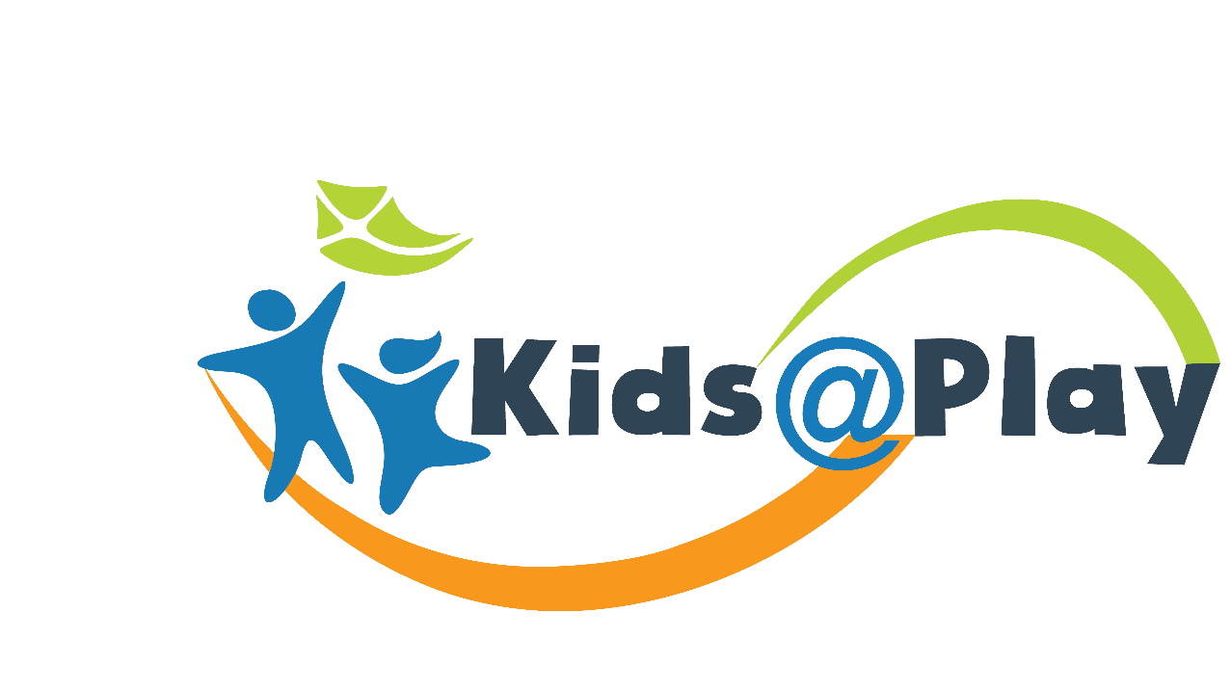
Free Fall Family Drop-In

Active free play, crafts, songs + games.
Healthy snack provided. No registration needed.
0-6 years + parents.

Mondays  Sept. 18 – Nov. 27  9:30-11:30 am  40 Mayfair Pl.  (Mayfair Recreation Centre) | Tuesdays  Sept. 19 – Dec. 12  9:30-11:30 am  465 Stafford St  (Bethel Mennonite Church) | Wednesdays  Sept 20 – Dec 13  9:30-11:30 am  725 Kylemore Ave.  (Lord Roberts C.C.)
Thursdays  Sept. 28 – Nov. 16  6:00-7:30 pm  1 Sir John Franklin Rd  (Sir John Franklin C.C.) | Saturdays  Sept 23 – Dec 2  9:30-11:30 am  1170 Corydon Ave  (Crescentwood Site of C.C.C.) | Coming Soon! Inspired Kids@Play  A new partnership with
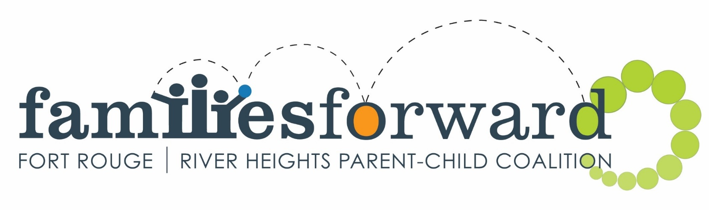
A community program by
Follow us on Facebook Families Forward – Fort Rouge/River Heights | www.families-forward.com

204.791.0956 | familiesforward@swfic.org | 204.804.7781

Supported by Healthy Child Manitoba “Putting children and families first”

