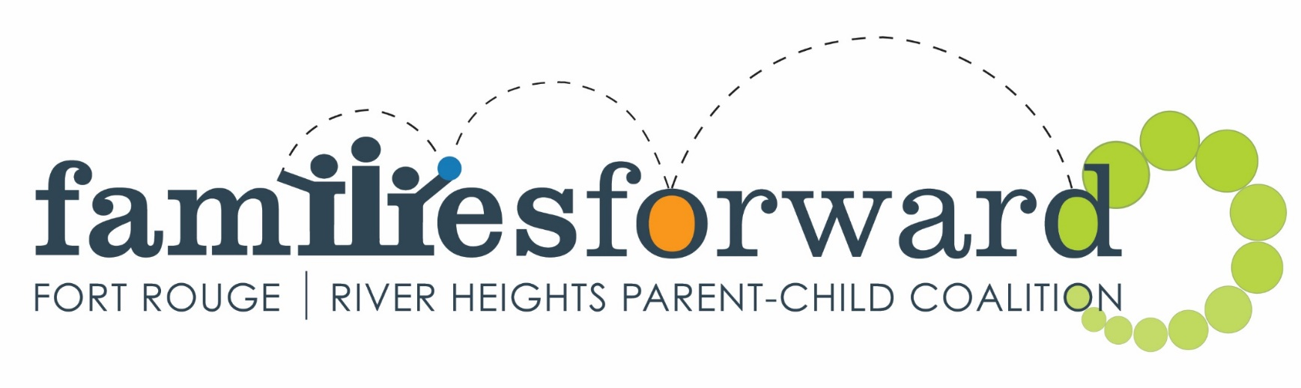

Invites you to come and play with
Physical Literacy...it's just a hop, skip and a jump to fun!

Fit Kids Healthy Kids is a Physical Literacy program founded as a partnership between Doctors Manitoba and Sport Manitoba. It teaches children and their adult leaders the fundamentals of movement that make kids confident and competent in sport, recreation, and life. The goal of the program is fit, healthy kids that are active for life. For more information visit: www.fitkidshealthykids.ca
Indoor Playground
Central Corydon C.C.
1370 Grosvenor Ave.
Apr. 6, 13, 20 and 27
10:00-11:00

Kids@Play
Bethel Mennonite Church
465 Stafford Ave.
Apr 26, May 3, 10 and 17
10:00-11:00

Rhyme and Story Time
Harrow United Church
955 Mulvey Ave.
Apr 29. May 6, 13 and 20
10:00-11:00
www.families-forward.com | 204.791.0956 | ffcoalition@hotmail.com
Follow us on Facebook Families Forward – Fort Rouge/River Heights

