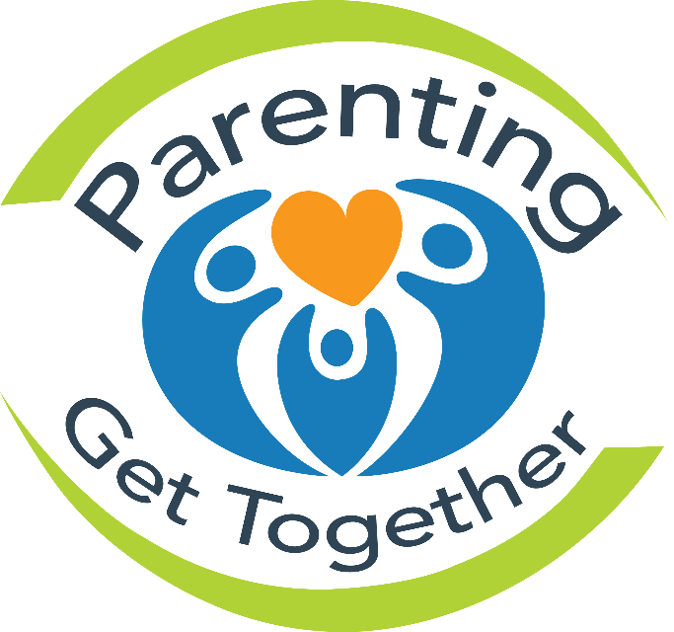
A time for new parents to learn, laugh and play with their babies.

Join us each month for a short presentation & a healthy snack.
Learn songs & rhymes with your baby.
Free, drop-in when you can. No registration required.

2nd Thursday of each month | 1:30-3:00
1370 Grosvenor Ave | Corydon Community Club - River Heights

Oct. 13, 2016 | Immunizations | Lorien Martens, Public Health Nurse
Nov. 10, 2016 | Infant Sleep | Lorien Martens, Public Health Nurse
Dec. 8, 2016 | Physical Fitness |Amanda Younka, Community Facilitator
Jan. 12, 2017 | Feeding your Infant Solids | Cheryl Ogaranko, Community Nutritionist.
Feb. 9, 2017 | Post-Partum Pelvic Floor Health | Denisha Thompson, Physiotherapist
March 9, 2017 | TBD

In partnership with the Public Health Nurses of River Heights
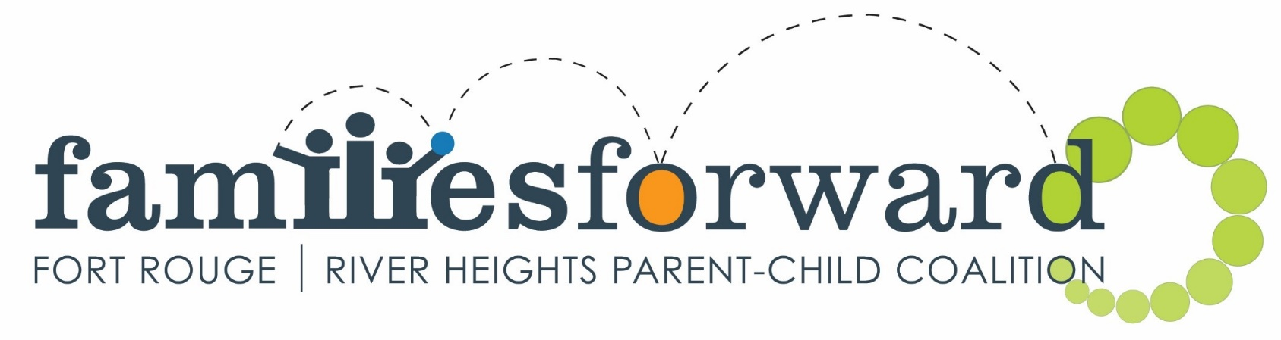

A community program by

